


Science and Technology Integrated with the SunSmart Program

Stage 3 Unit of Work- Year 6

OUT IN SPACE  Looking at environments beyond earth | □ Early Stage 1  □ Stage 1  □ Stage 2  √ Stage 3 |  |  |  | Notes:  This SunSmart unit forms a sub-unit of the ‘Out in Space’ unit and assumes that children have completed prior tasks in the investigation of the solar system.  This unit is designed for approx 4 weeks.  Assessment tasks are indicated with A
Year
6

Unit purpose and focus: Why is ultraviolet radiation a problem?

This unit provides opportunities for students to further develop their knowledge and understanding that: living things show variation within a species; the activities of people can change the balance of nature with particular reference to the high incidence of skin cancer in Australia; groups of living things have changed over long periods of time; and information can be presented in a number of different forms.
Rationale for Integration:
This unit of work is designed to be delivered as either part of the Science and Technology Scope and Sequence or the Connected Outcome Groups (COGS). Please note the same outcomes are addressed. We know that children gain a greater understanding of issues and topics through investigating and the ‘learning processes’ in the Science and Technology Curriculum is ideal as it encourages discovery learning.

At the conclusion of this unit students will understand that it is not just the heat of the sun that is dangerous; what ultraviolet radiation is and how to measure it; and that we need to take specific precautions to protect ourselves from the effects of ultraviolet radiation.

Learning process outcomes and big ideas |  |  | Content strand outcomes and big ideas |  |  |  | Values and attitudes
Investigating INV S3.7  Conducts their own investigations and makes judgements based on the results of observing, questioning, planning, predicting, testing, collecting, recording and analysing data, and drawing conclusions.  Big ideas  - Investigates ultraviolet (UV) radiation.  - Investigates the effects of ultraviolet (UV) radiation.  Using Technology UT S3.9  Evaluates, selects and uses a range of equipment, computer-based technology, materials and other resources to meet the requirements and constraints of investigation and design tasks.  Big ideas  - Investigate the Cancer Council website for understanding of UV.  - Uses the Bureau of Meteorology website on a daily basis.  Designing and Making DM S3.8  Develops and resolves a design task by planning, implementing, managing and evaluating design processes.  Big Ideas  - Creates a procedure or system to inform the school community about the UV Index on a daily basis.  - Designs a poster to inform others about UV radiation and its effects in our lives. |  |  | Living Things LT S3.3  Identifies, describes and evaluates the interactions between living things and their effects on the environment.  Big Ideas  - Identifies the importance of the sun.  - Investigates the harmful effects of UV radiation and the sun.  Information and Communication IC S3.2  Creates and evaluates information products and processes, demonstrating consideration of the type of media, form, audience and ethical issues.  Big Ideas  - Informs the school community of the UV Index on a daily basis.  Earth and Its Surroundings ES S3.6  Recognises that the earth is the source of most materials and resources, and describes phenomena and processes, both natural and human, that form and change the earth over time.  Big ideas  - Investigates the relationship between the earth and the sun.  Products and Services PS S3.5  Identifies and applies processes involved in manipulating, using and changing the form of energy.  Big Ideas  Provides the UV Index for school. |  |  |  | Students will:  - Demonstrate confidence in themselves and willingness to make decisions and to take responsible actions.  - Show flexibility and responsiveness to ideas.  - Exhibit self direction in their own learning.  - Show a commitment to fair treatment to all.  - Be honest and open in their dealings with others.  - Be curious about and appreciate the natural and made environment.  - Appreciate the scientific and technological contribution made by Australians and members of other societies and cultures.  - Appreciate education as a continuing process.
Task: Investigate ultraviolet radiation and the sun’s harmful effects on earth |  |  |  | Task: Design and make a school UV Indicator
Observing and exploring  - Explore what students know about ultraviolet radiation and what they would like to know.  - Brainstorm ideas on the whiteboard.  - Revisit previous units of work and recall facts (refer to Stage 2 Year 3 and Stage 3 Year 5) about the harmful effects of UV radiation and how we can minimise our risk of skin cancer in later life.  - Explore the Cancer Council http://www.cancercouncil.com.au/editorial.asp?pageid=1847 website.  - Write an Information Report about 3 types of UV Radiation - A. |  |  |  | Identifying needs and wants  - Ask students what they know about UV radiation and how it affects us.  - Redefine the relationship between the earth and the sun.  - Identify the need for understanding how we measure UV radiation and why we need to be aware of the UV Index.  - Determine how to share the information gained about UV radiation and how to pass this information on to the school community.
Hypothesising and predicting  - Predict what it is about UV radiation that is harmful.  - List their predictions.  - Hypothesise when the UV levels would be more harmful.  - Predict what protects the earth from the harmful effects of the sun.  - Hypothesise about the relationship between the ozone layer and UV. |  |  |  | Generating and selecting ideas  - Brainstorm ideas about UV radiation and its effects.  - Examine UV Alerts in other Australian states.  - Make suggestions about how we could help more members of the school community become aware of the effects of UV radiation.  - Make a poster with information about UV radiation - A.
Devising and testing  - Investigate the 3 types of UV radiation.  - Investigate and revisit the relationship between the earth and the sun.  - Investigate the earth’s atmosphere and the ozone layer.  - Investigate UV Alerts in other parts of Australia.  - Investigate vitamin D. |  |  |  | Using resources to create products and services  - Use the Cancer Council website, newspapers and other sources to gain information about UV radiation.  - Design a poster.  - Create a UV indicator for the school community to use.
Collecting and recording  - Types of UV radiation and facts list.  - Data from other Australian states / UV Alerts.  - UV information for poster.  - UV Index.  - Information Report- A |  |  |  | Evaluating products and services  - Observe other students’ behaviour in the sun at school.  - Talk to individual classes about how to use the UV indicator.
Analysing and drawing conclusions  - Each week ask the students to discuss their investigation.  - Conclude the unit by asking students if they now understand why UV radiation is such a concern.  - Were their predictions correct? How were they different?  - Children create a UV Index and inform the school community of its daily reading. |  |  |  | Essential Background Information for Teachers  Refer to Cancer Council NSW http://www.cancercouncil.com.au/editorial.asp?pageid=1847 website and Bureau of Meteorology website for information about the UV Index http://www.bom.gov.au/weather/uv/
Assessment items

Activity 1 - Write an Information Report about the 3 types of UV radiation and a Facts List about UV - Sample.
A Create your own SunSmart UV Alerts - Sample; Explanation and Demonstration.
Activity 2 - Design and make a poster about UV - Sample; Explanation and Demonstration.
A Design and make a UV Indicator for the school community to use - Sample, Explanation/Demonstration/Observation.
A Make generalisations about the effects of UV radiation - Teacher observation and notes.

Links to other learning areas

PDHPE - Health and Safety
Mathematics - Data, DS 3.1
English - Writing WS 3.9; Information Report; Talking and Listening TS 3.1:
HSIE – CU S3.3
Computer Technology Link – UT S3.9

On Line resources  Explore the Cancer Council http://www.cancercouncil.com.au/editorial.asp?pageid=1847 website and Bureau of Meteorology for information about the UV Index http://www.bom.gov.au/weather/uv/ |  | Equipment and materials  Information Sheets  Newspapers  Worksheets  Assessment Sheets/Tasks  Material for Indicator  Computers |  |  |  | Other people/places  UV Index in other countries
Teacher reflections and unit evaluation

Stage 3 – Out in Space
An investigation into UV radiation and how to inform the school community.

Year 6

Outcomes | Teaching & Learning Activity | Teacher’s Comment/  Observation
1  INV S3.7  UT S3.9  LT S3.3 | - Explore what students know about ultraviolet (UV) radiation.  - Brainstorm ideas on the whiteboard.  - Children predict what they think they might find out about the effects of UV radiation.  - Explore and investigate the Cancer Council website: www.cancercouncil.com.au/sunsmart and Bureau of Meteorology for information about the UV Index http://www.bom.gov.au/weather/uv/  - Understand UV radiation.  - Discuss findings.  - Activity 1 - Write an Information Report about the three types of UV radiation and a Facts list about UV raditaion- A  - Recall facts previously learnt about the relationship between the sun and the earth with particular reference to seasons – ask students to demonstrate the position of the earth and sun with a globe and tennis ball.  - Predict when the UV rays would be more harmful.
2  INV S3.7  LT S3.3  ES S3.6 | - Investigate the UV Index and peak times for Sydney – complete Activity 3 Weather Watch.  - Investigate the UV Index for other capital cities – complete Activity 4 Radiation levels – our findings.  - Ask: What protects the earth from the harmful effects of the sun?  - Discuss the ozone layer. Predict what effect it might have on the intensity of UV radiation.  - Complete Activity 5 Ozone - the Earth’s screen.  - Examine and discuss Activity 6 SunSmart UV alerts from different places around Australia.  - Imagine you work at the Bureau of Meteorology. Create your own SunSmart UV Alerts and explain it to a buddy. A  - Complete Activity 7 UV Index Number Puzzle.  - Investigate: What is vitamin D, where do we get it from and why do we need it? Review www.cancercouncil.com.au/sunsmart  for further information.  - Discuss findings.
3  DM S3.8  IC S3.2  PS S3.5 | Class Project:  - Activity 2 - Design and make a poster that can be displayed at school. A  - The purpose of the poster is to inform the school community about UV radiation.  - Your poster should include the following information:  - A definition for UV radiation.  - Important facts about UV.  - Vitamin D – definition and source.  - The amount of vitamin D needed.  - Some people who might need more vitamin D.
4  LT S3.3  DM S3.8  PS S3.5  IC S3.2 | - Discuss ways of informing our school community about the daily readings of UV Index.  - Design and make a UV Alert that can be used by the school community – A.  - Children work in groups.  - It would be a good idea to ensure that there are enough Alerts created so that each class would have one and that there would also be one for the playground.  - Decide elements to be incorporated in the Alert.  - Select materials that will withstand time and weather constraints.  - Discuss how the indicators will be changed on a daily basis, who is responsible and when the Alert will be set.  - Once designed and made present to the appropriate class and explain.  - Make generalisations about the investigation and conclude the unit by asking students if they now understand what UV radiation is and the long-term effects it can have on our lives.

Activity Sheet 1
KLA: Science and Technology
Stage: Stage 3
Outcomes: INV S3.7, LT S3.3, WS 3.9
Task: Investigate the three different types of UV radiation
Activity: Write an information report on the findings

Information Report
Introduction:

UVA:

UVB:

UVC:

Facts about UV radiation:

Temperature:

Clouds:

Surfaces:

Factors Affecting UV radiation levels:

Summary/Conclusion:

Activity Sheet 2
KLA: Science and Technology
Stage: Stage 3
Outcomes: DM S3.8
Task: Design and make a poster that informs people about the effects of UV radiation
Activity: Make a poster

Activity Sheet 3
KLA: Science and Technology
Stage: Stage 3
Activity: Complete the worksheet on Weather Watch

Weather Watch

Record the UV Index for a week by visiting the Bureau of Meteorology or checking the weather section of the daily newspapers.

Day | Describe the weather | UV Index
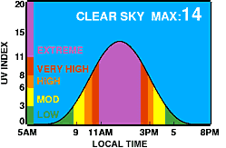

Activity Sheet 4
KLA: Science and Technology
Stage: Stage 3
Activity: Complete the worksheet on UV radiation

Refer to the table below to answer these questions.
- Which NSW towns have the lowest UV Index?
______________________________________________________________________________________________________________________________________________________
2. When the UV Index is 3 and above what should we do to protect ourselves?
______________________________________________________________________________________________________________________________________________________
3. Draw a bar graph using the UV Index for these NSW towns.

NEW SOUTH WALES

UV Index Forecast Valid Wednesday 24 September 2008
 | UV Alert between  (local time) | Maximum  UV Index | UV Alert between  (local time) | Maximum  UV Index | Maximum  UV Index
Albury | 9.20 am to 2.40 pm | 5 | Forster | 8.50 am to 2.30 pm | 6
Armidale | 8.40 am to 2.50 pm | 7 | Glen Innes | 8.40 am to 2.50 pm | 7
Batemans Bay | 9.10 am to 2.40 pm | 6 | Gosford | 9.00 am to 2.30 pm | 6
Bathurst | 9.00 am to 2.50 pm | 7 | Goulburn | 9.00 am to 2.40 pm | 7
Bourke | 9.10 am to 3.10 pm | 7 | Grafton | 8.40 am to 2.40 pm | 7
Bowral | 9.00 am to 2.40 pm | 7 | Griffith | 9.20 am to 2.50 pm | 6
Broken Hill | 9.30 am to 3.20 pm | 7 | Inverell | 8.40 am to 2.50 pm | 7
Cabramurra | 9.10 am to 2.50 pm | 6 | Ivanhoe | 9.20 am to 3.00 pm | 6
Canberra | 9.10 am to 2.40 pm | 6 | Katoomba | 8.50 am to 2.50 pm | 7
Cape Byron | 8.40 am to 2.40 pm | 7 | Kempsey | 8.40 am to 2.40 pm | 7
Cessnock | 9.00 am to 2.40 pm | 6 | Lismore | 8.40 am to 2.40 pm | 7
Cobar | 9.10 am to 3.10 pm | 7 | Lithgow | 8.50 am to 2.50 pm | 7
Coffs Harbour | 8.40 am to 2.40 pm | 7 | Maitland NSW | 9.00 am to 2.30 pm | 6
Cooma | 9.10 am to 2.40 pm | 6 | Merimbula | 9.10 am to 2.40 pm | 5
Deniliquin | 9.40 am to 2.50 pm | 5 | Moree | 8.50 am to 2.50 pm | 7
Dubbo | 9.00 am to 2.50 pm | 7 | Mudgee | 9.00 am to 2.50 pm | 7

Activity Sheet 5
KLA: Science and Technology
Stage: Stage 3
Activity: Complete the worksheet on the ozone layer

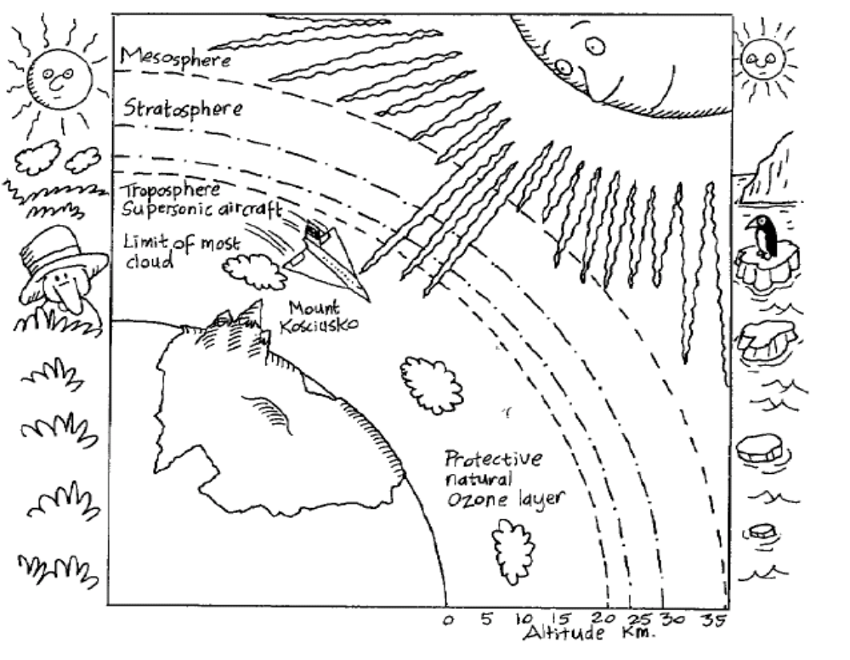

What would happen to people, plants or animals if the ozone layer is damaged?

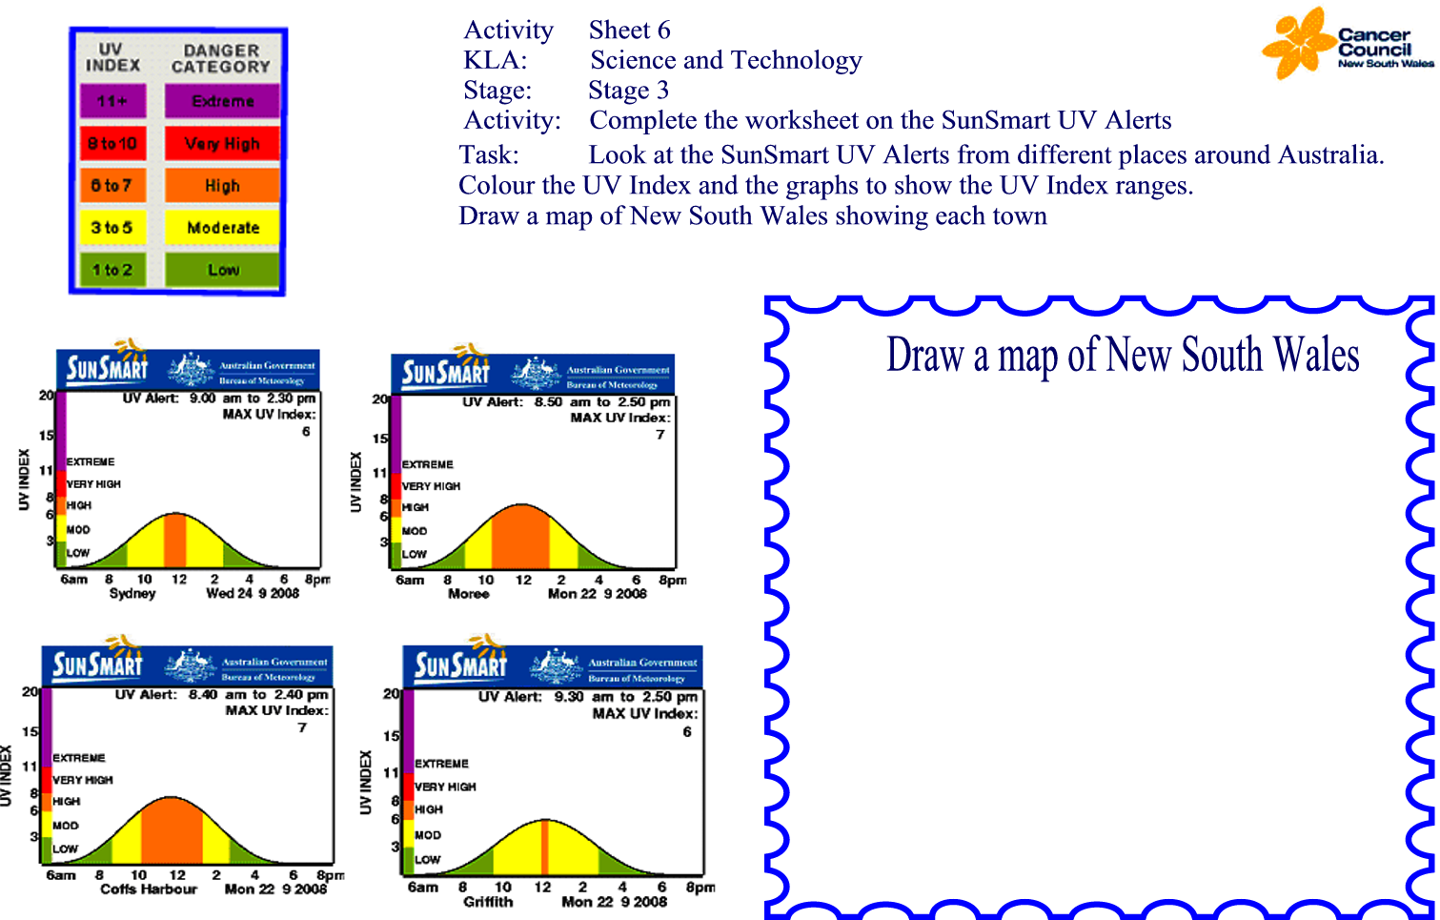

Activity Sheet 7
KLA: Science and Technology
Stage: Stage 3
Activity: Complete the worksheet on the UV Index Number Puzzle

Can you find the missing numbers? Just like the UV Index the missing numbers are from 1 to 11.
- The numbers in each row add up to the totals to the right.
- The numbers in each column add up to the totals along the bottom.
- The diagonal lines also add up to the totals to the right.
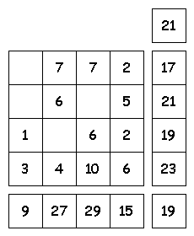

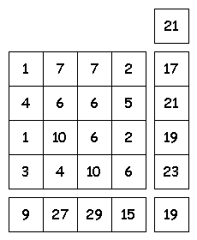

UV Index Number Puzzle
Solution to Activity 7

