Cluster | Text Structure | Purpose |  |  | Language Features
 | Structure | Audience | Ideas | Devices | Vocabulary | Cohesion | Paragraphing | Sentence Structure | Punctuation | Spelling
1 | No clear message (BPS) | No audience (BPS) | No content | No devices (1 mark)  (BPS) | Attempts to record words of personal significance eg name(EAfS) | No cohesion (BPS) | No evidence ( 1 mark)  (BPS) | No evidence of sentence structure (EAfS) | No evidence of punctuation. (EAfS) | Random letter/letter like symbols. (EAfS)
2 | Attempts to record their message (BPS) | Attempts to compose texts known audience e.g. self  (BPS) | Random words |  | Records of personal significance eg own name or those of family members.(EAfS) | No links, confusing for the reader.  (BPS) |  | Random words  (EAfS) | Random use of capital letters and/or full stops.  (EAfS) | Writes approximate letters for some sounds. Clear attempt to write name or a recognisable word.(EAfS)
3 | Simple text recording ideas and events. (BPS) | Compose texts for known audience, e.g. teacher.  (BPS) | Text contains one idea OR ideas appear unrelated to each other OR ideas are unrelated to topic on prompt (NAP) | Imaginative – Only names characters or gives their roles. Only names the setting. No other devices.(NAP) | Uses familiar, common words and simple high frequency words.  (EAfS) | Links are missing or incorrect. Short script. Often confusing for the reader (NAP) |  | Shows an awareness of correct sentence parts. Meaning may be unclear. Uses simple noun groups and adverbial phrases.  (EAfS) | Some use of capital letters and/or full stops.  (EAfS) | Records beginning and ending sounds.  Spells simple HFW correctly eg to, is my, is, can and words of personal significance.  Begins to use word walls to write unknown words. (EAfS) (CL3)
4 | Short text exploring ideas and events that may be altered according to purpose. (BPS) | Compose texts for known audience, e.g. class, other classes and parents.  (BPS) | Two related ideas. May also include other unrelated ideas.  (EAfS) | Imaginative - Names at least one character and/or mentions setting.  Informative – contains at least two basic facts. | Uses every day vocabulary including proper nouns particular to cultural context.  (EAfS) | Evidence of links but sometimes incorrect. Short script. Still confusing for the reader.  (BPS) | Attempts to separate sentences in paragraphs.  (BPS) | Writes simple sentences, meaning is clear. Produces some compound sentences using conjunctions.  Uses simple pronoun references. (EAfS) | Evidence of capital letters and full stops at the start and end of sentences. (EAfS) | Spells unknown words phonetically with most letters in the correct sequence. Correctly spells HFW went,come and said. Uses word endings eg boy/ boys, looked/looking (EAfS)
5 | Minimal evidence of imaginative, informative or persuasive structure. Structural components not clearly identifiable  OR one component only, e.g. an introduction or body (NAP) | Response to audience needs is limited. Contains some simple written content. Text is very short or difficult to make any meaning from. (NAP) | Three related ideas may include other unrelated ideas.  (EAfS) | Imaginative – Names two characters and/or setting  Informative – Contains more than 4 facts.  Persuasive – Begins to express opinion in writing  (BPS) | Uses a range of vocabulary, include topic specific words. Selects and use vocabulary and phrases from shared literacy experiences and class discussion. (EAfS) | Links in thoughts and ideas mostly correct. (BPS) | Begins to use texts features such as paragraphs.  (EAfS) | Accurately writes 4 or more simple and compound sentences.  Uses a range of adjectives and adverbial phrases. (EAfS) | Consistent use of sentence punctuation (capital/full stop). May include evidence of simple punctuation e.g. ? ! (CL5) (EAfS) | Spells unknown words phonetically with letters in the correct sequence.  Uses correct prefixes and suffixes. HFW eg they after, your. (EAfS)
6 | Imaginative – story has a clear ending  Informative – one component is clearly identifiable within text  Persuasive - one component is clearly identifiable within text (BPS) | Text is short. Re-reading is essential to gain meaning.  (BPS)  Elementary evidence of revision of editing. (CL6) | Four or more sequenced ideas clearly connected.  (EAfS) | Imaginative – Creates characters and key events.  Informative – all facts are correct, related and supported (more than 4).  Persuasive – begins to use modal language e.g. I think…, I believe …, (BPS) | Demonstrates the use of more precise vocabulary choices to describe feelings, experiences and actions. Selects a variety of stringer verbs e.g. scrambles, slithers. (EAfS) | Writes a sequence of thoughts and ideas. (CL6) | Intentionally uses text features such and headings and/or paragraphs to organise information. (EAfS/BPS) | A variety of sentence structures: simple, compound and complex, some variation in beginnings. Correct pronoun referencing. Time connective to sequence ideas. (EAfS) | Correct use of capital letters. Uses simple punctuation e.g. full stops, !, ? to end sentences  (CL6) (EAfS) | Spells unfamiliar words using strategies such as using analogy and known chunks and rhymes.Uses more complex word endings e.g. ly, est, ist, es.  HFW words house, friend, because (EAfS)
7 | Imaginative – story has clear beginning and ending.  Informative – some evidence of two possibly weak components.  Persuasive - – some evidence of two possibly weak components (BPS) | Selects a text structure to suit purpose and audience.(EAfS)  Some evidence of text revision, meaning is clear but text may need to be re-read.  (BPS) | One idea with simple elaboration OR ideas are few and related but not elaborated OR many simple ideas that are related but not elaborated (NAP) 5 or more ideas. | Imaginative – Composes a text that makes inferences about characters qualities and/or characteristics. (EN1-7b)  Informative - text is supported by simple visual information including diagrams and maps on familiar topics. (EN1-7b)  Persuasive - Draws on personal experience and topic knowledge to express opinions in writing. (EN1-2a) | Experiments with literary devices such as alliteration, onomatopoeia, to enhance and enrich meaning.  Uses words from intentional class vocabulary lists in own writing. (EAfS) | Writes short and connected sequenced text to narrate events or convey information. (CL7) | Consistently using paragraphs to groups ideas.(EAfS) | Includes different type of verbs using appropriate tense and demonstrates subject verb agreement.  Writes sentences that are connected and sequenced to narrate events or to convey information.(EAfS) | Use a range of sentence punctuation correctly. Consistently uses capital for proper nouns. Some evidence of contractions, apostrophes and commas. (EAfS) | Spells words using consonant blends, vowel diagraphs and silent letters that have been explicitly taught.  (EAfS)
8 | Imaginative – experiments with complication  Informative – One clearly identifiable component and second component is present but weak  Persuasive - One clearly identifiable component and second component is present but weak (BPS) | Composes complex texts which show strong evidence of purpose and audience. (EAfS)  Meaning is clear with evidence of revision and editing to assist audience meaning. (BPS) | More than one elaborated idea.  (BPS)  Draws on personal experience and feelings as subject matter. (EN1-7B) | Imaginative – Composes texts that make inferences about characters including motives, actions, qualities and characteristics. (EN1-7b)  Informative – some more complex technical language is introduced inconsistencies may be apparent.  Persuasive – uses a statement or statements of personal opinion and/or beginning devices. (BPS) | Correct use of technically specific vocabulary.  Use of figurative language such as metaphor and/or simile. Uses words and phrases for effect, to create atmosphere or add emphasis. (EAfS) | Writing is connected and sequenced (BPS)  Begins to make a conscious choice of vocabulary to suit purpose and audience.  (EN1-7b) | Begins paragraphs with topic sentence introducing the theme or idea.  (EAfS) | Demonstrates variety in sentence structures, sentence length, and uses a range of sentence beginning. Sentences flow with logically sequence showing consistent use of tense. Experiments with direct and indirect speech. (EAfS) | Demonstrates control over a variety of punctuation to enhance text meaning e.g. quotation marks for direct speech and commas in lists (EAfS) | Use of some irregular spelling patterns e.g. light, cough  Application of spelling rules e.g. hop/hopping  hope/ hoping, HFW including where/were/ why/who (EAfS)
9  Constructs well-sequenced imaginative,  informative and persuasive texts using language appropriate to purpose and  audience. | Imaginative – Contains a beginning and a complication. Resolution is present but weak. (NAP) | Internally consistent text that attempts to support the reader by developing a shared understanding of context – i.e. contains sufficient information for the reader to follow the text easily (NAP) | Ideas are supported with some elaboration OR many unelaborated ideas that relate plausibly (4 or more) OR one idea with more developed elaboration (NAP) | Imaginative – Brief description of a character and setting but lacks consistency. (NAP) | Uses verbs, adverbials, nouns and adjectives to express specific ideas and details.(CL9)  Experiments with figurative language when composing texts to engage an audience, eg similes, metaphors, idioms and personification EN2-9B | Meaning is clear on first reading. Links are clear however short script.  (BPS) | Paragraphs are composed  of logically grouped sentences are focused  a particular aspect of a topic. (CL9)  At least one paragraph is logically constructed and contains a topic sentence and supporting detail paragraphs are correct but basic. (NAP) | Simple and compound sentences are correct and most complex sentences are correct. Meaning is clear. (NAP)  Uses grammatical features to create complex sentences when composing texts EN2-9B | Sentence level punctuation mostly correct (minimum of 80% of 5 sentences  punctuated correctly) AND some other correct punctuation (two or more examples of different types of other punctuation) (NAP) | Uses a variety of spelling strategies to spell high frequency words correctly. (CL9)
 | Informative – Text contains two clearly identifiable structural components OR all components are present but weak (NAP) |  |  | Informative – Some correct use of technical language. Graphic, pictures, tables, and charts, etc are present and are mostly supplementary to understanding the text (NAP)
 | Persuasive – Text contains two clearly identifiable structural components OR all components are present but weak (NAP) |  |  | Persuasive – Uses a statement or statements of personal opinion AND/OR one or two devices (NAP)
10  Draws ideas from personal experiences,  other texts and research to create  imaginative, informative and persuasive texts for different audiences. | Imaginative – Characterisation emerges through descriptions, actions or speech. Setting emerges through description of place and time. (NAP) | Supports reader understanding and attempts to:  engage  inform or  persuade the reader. (NAP) | Multiple ideas show two or more examples of elaboration. (3 or more)(BPS) | Imaginative – creates imaginative texts based on characters, settings and events from students' own and other cultures EN2-2A | Adapts language features and patterns encountered in literary texts, for example characterisation, rhyme, rhythm, mood, music, sound effects and dialogue EN2-2A Incorporates new vocabulary from a range of sources into students' own texts including vocabulary encountered in research EN2-9B | Uses grammatical features such as  pronouns, conjunctions and connectives to  accurately link ideas and information. (CL10) EN2-9B Controlled use of cohesive devices support reader understanding. Meaning is clear on first reading and text flows well in a sustained piece of writing (NAP) | Three or more paragraphs are logically constructed and contain a topic sentence and supporting detail. Paragraphs are correct however still basic. (BPS) | Creates meaningful sentences using a  variety of sentence beginnings, including  adverbial and adjectival clauses to create  complex sentences.(CL10) | All sentence punctuation correct. Mostly correct use of other punctuation (NAP)  Uses sentence and simple punctuation  correctly. (CL10) | Correct spelling of most simple words and most common words.  (NAP)  Uses morphemic, visual, phonic knowledge  and knowledge of prefixes and suffixes to spell and edit words.(CL10)
 | Informative – Text contains three clearly identifiable structural components (BPS) |  |  | Informative – correct use of basic technical language. Beginning to develop ideas. (BPS)
 | Persuasive – Shows awareness of the need to justify opinions with supporting evidence. (NAP)  Text contains three clearly identifiable structural components (BPS) |  |  | Persuasive –express a point of view for a particular purpose in writing, with supporting arguments and make constructive statements that agree/disagree with an issue EN2-7B
11  Writes coherent, structured texts for a range of purposes and contexts. Deliberately structures language in a way that creates more cohesive imaginative,  informative and persuasive texts. | Imaginative – All components are present. Characterisation clearly developed through detailed descriptions, actions or speech. Setting is integral to plot. (BPS) | Uses more challenging language features, literary devices (eg irony, humour) to engage and influence an audience EN3-6B | Ideas are elaborated and contribute effectively to the writer’s position.  Ideas may be elaborated by playing one side against the other, a refutation of other positions or opinions, explaining cause and effect (NAP) | Imaginative – Experiments with the use of imagery in imaginative texts, poetry and songs, eg similes, metaphors, personification and sound devices such as alliteration EN3-2A | Selects appropriate language for purpose,  e.g. descriptive, persuasive, topic, technical,  evaluative, emotive, and colloquial. (CL10) EN3-6B | Cohesive links are made in texts by omitting or replacing words EN3-2A | Uses topic sentences and appropriately  organises main and subordinate ideas.(CL10) EN3-6B | Sentences correct. Demonstrates variety. Meaning is clear and sentences enhance meaning. (NAP)  Complex sentences can be used in a variety of ways to elaborate, extend and explain ideas EN3-2A | Experiments with using complex  punctuation to engage the reader and achieve purpose. (CL10) | Correct spelling of simple words, most common words, some difficult words (NAP)  Applies knowledge of generalisations,  meanings of base words and word parts  (prefixes and suffixes) to spell new words. (CL10)
 | Informative – All components are present and show some development (BPS) |  |  | Informative – Shows evidence of developed ideas EN3-2A Correct use of technical language. (BPS)
 | Persuasive – All components are present with coherent and developed arguments, clearly supporting opinions with evidence. (NAP) |  |  | Persuasive Include sustained and effective use of persuasive devices, eg texts dealing with environmental issues EN3-2A
12  Creates well planned, extended texts that  include more complex and detailed subject  matter and language features. | Imaginative – Coherent, controlled and complete narrative. Employs effective plot devices.(NAP) | Makes choices about the type and form of  texts, including combinations of forms and  types, to suit purpose and audience.(CL12)  Supports, engages/informs/  persuades the reader through deliberate language choices and techniques (NAP)  Uses more challenging grammatical features (eg modality) to engage and influence an audience EN3-6B | Ideas are specifically selected to be engaging, informative or persuasive. Ideas may be elaborated by playing one side against the other, a refutation of other positions or opinions, explaining cause and effect (BPS) | Imaginative – Selects some sophisticated and subtle literary devices (e.g irony, humour) to engage and influence an audience.(CL12)  Details of characters are selected to create realistic characters. Maintains are setting throughout. (NAP) | Selects some sophisticated and subtle  language features (CL12)  Ideas and points of view in texts are conveyed through the use of vocabulary, including idiomatic expressions, objective and subjective language EN3-6B  Sustained and consistent use of precise words and word groups that enhance meaning (may be some inaccurate or inappropriate word groups) (NAP) | Cohesive devices are used correctly to enhance reading and support underlying relationship. Writing is extended and shows continuity of ideas (BPS)) | Paragraphs are ordered and cumulatively build ideas across text (NAP)  Introduction  Conclusion | Makes sentence level choices (e.g. short  sentences to build tension; complex sentences to add detail) using a variety of sentence  beginnings and dependent clause . (CL12)  All sentences are correct. Writing contains controlled and well-developed sentences that express precise meaning and are consistently effective (NAP)  Uses different types of sentences, eg short sentences to build tension and complex sentences to add detail EN3-6B | Uses a range of punctuation to enhance meaning and clarity, including the use of  brackets to enclose additional information,  quotation marks and commas to indicate  clauses.(CL12) | Integrates a range of spelling strategies and conventions to accurately spell most words, including words of many syllables.(CL12)  Correct spelling of simple words, most common words, 10 difficult (NAP)
 | Informative – Coherent, controlled and complete information. All components are well developed. (NAP) |  |  | Informative – Use of technical language is integral to the text.  Graphics support or are integral to understanding(NAP)
 | Persuasive – Coherent, controlled and complete arguments. All components are well developed. Introduction with clear position statement + EITHER body with reasons and detailed supporting evidence OR conclusion that reinforces the writer’s position. (NAP) |  |  | Persuasive – Uses some devices that persuade. Use is effective but not sustained (may also include some ineffective use) (NAP)
13+  Creates well-structured and sequenced texts for imaginative, informative and persuasive purposes. | Persuasive – Coherent, controlled and complete arguments. All components are well developed. Introduction with clear position statement AND body with reasons and detailed supporting evidence AND conclusion that reinforces the writer’s position. (NAP) | Controls writer/reader relationship. Establishes strong, credible voice. Crafts writing to influence reader by precise and sustained language choices and techniques. Takes readers’ values and expectations into account (NAP) | Ideas are generated, selected and crafted to be highly engaging, informative or persuasive. Ideas may be elaborated by playing one side against the other, a refutation of other positions or opinions, explaining cause and effect (NAP)  Creates and develops ideas to explore a concept or theme.(CL13) | Imaginative – | A range of precise and effective words and word groups used in a fluent and articulate manner. Language use is well matched to style.(NAP) | A range of cohesive devices is used correctly and deliberately to enhance reading and support underlying relationship. An extended, highly cohesive piece of writing showing continuity of ideas and tightly linked sections of text (NAP) | Uses paragraphing to structure information and partition events and ideas.(CL13) | Intentionally constructs a variety of sentence types including complex sentences for effect. (CL13) | Writing contains accurate use of all applicable punctuation. A wide variety of punctuation is used correctly including direct speech, semi colon and colon :(NAP)  Uses correct and appropriate punctuation to support meaning. (CL13) | Correct spelling of all words, 10+ difficult ones some challenging words (NAP)  Self-regulates spelling and applies spelling knowledge and strategies to spell complex and subject specific vocabulary. (CL13)
Informative – Technical language is used to enhance understanding.
Graphics are intricate, extensive and are integral to making meaning of the text; may provide information not otherwise conveyed in the text (NAP)
 |  |  |  | Persuasive – Sustained and effective use of persuasive devices. Effective devices are appropriate to style of argument and may appeal to one or more of the reader’s reason, values or emotions (NAP)

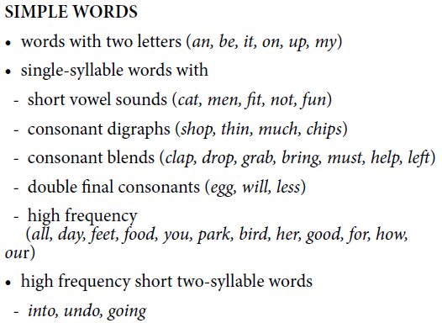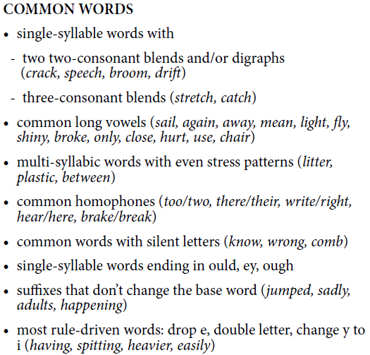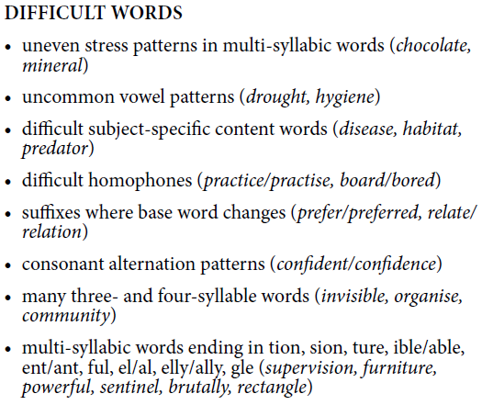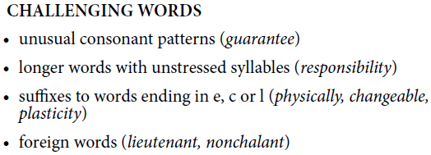

Text Structure - Structure
Cluster 9  Imaginative – Contains a beginning and a complication. Resolution is present but weak. (NAP)  Informative – Text contains two clearly identifiable structural components OR all components are present but weak (NAP)  Persuasive – Text contains two clearly identifiable structural components OR all components are present but weak (NAP) | 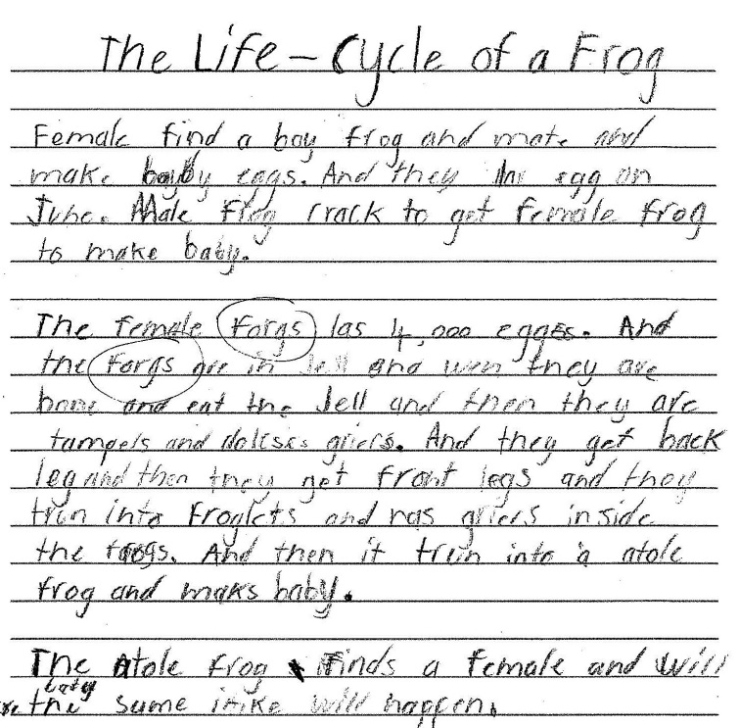 | Cluster 10  Imaginative – Characterisation emerges through descriptions, actions or speech. Setting emerges through description of place and time. (NAP)  Informative –  Persuasive – Shows awareness of the need to justify opinions with supporting evidence. (NAP)
Cluster 11 |  | Cluster 12  Imaginative – Coherent, controlled and complete narrative. Employs effective plot devices.(NAP)  Informative –  Coherent, controlled and complete information. All components are well developed. (NAP)  Persuasive – Coherent, controlled and complete arguments. All components are well developed. Introduction with clear position statement AND body with reasons and detailed supporting evidence AND conclusion that reinforces the writer’s position. (NAP)

Purpose - Audience
Cluster 9  Internally consistent text that attempts to support the reader by developing a shared understanding of context – i.e. contains sufficient information for the reader to follow the text easily (NAP) | 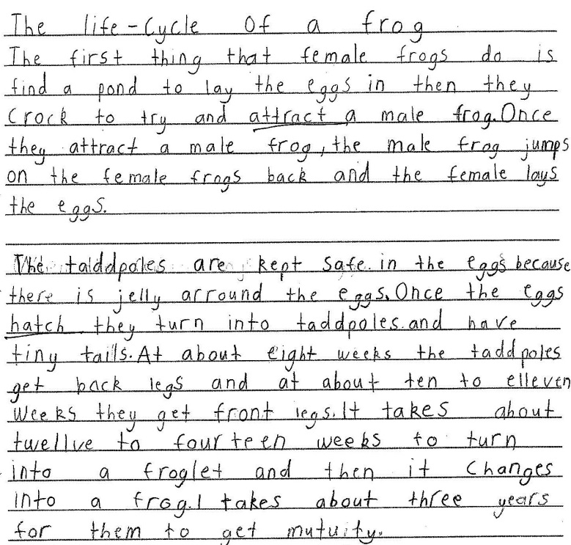 | Cluster 10  Supports reader understanding and attempts to:  engage  inform or  persuade the reader. (NAP)
Cluster 11  Uses more challenging language features, literary devices (eg irony, humour) to engage and influence an audience EN3-6B | 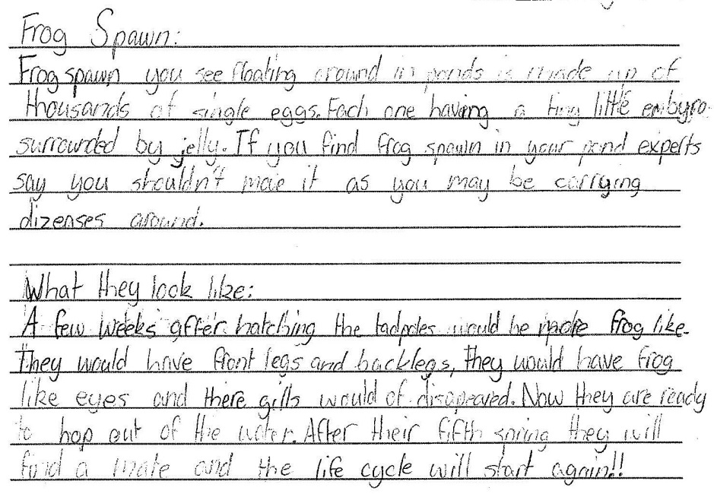 | Cluster 12  Makes choices about the type and form of  texts, including combinations of forms and  types, to suit purpose and audience.(CL12)  Supports, engages/informs/  persuades the reader through deliberate language choices and techniques (NAP)  Uses more challenging grammatical features (eg modality) to engage and influence an audience EN3-6B

Purpose - Ideas
Cluster 9  Ideas are supported with some elaboration OR many unelaborated ideas that relate plausibly (4 or more) OR one idea with more developed elaboration (NAP) | 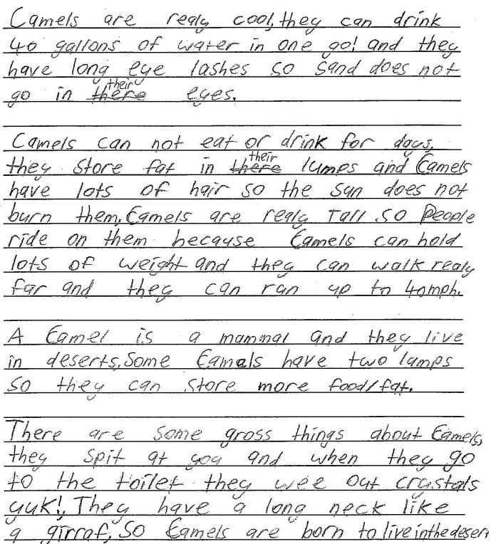 | Cluster 10
Cluster 11  Ideas are elaborated and contribute effectively to the writer’s position.  Ideas may be elaborated by playing one side against the other, a refutation of other positions or opinions, explaining cause and effect (NAP) | 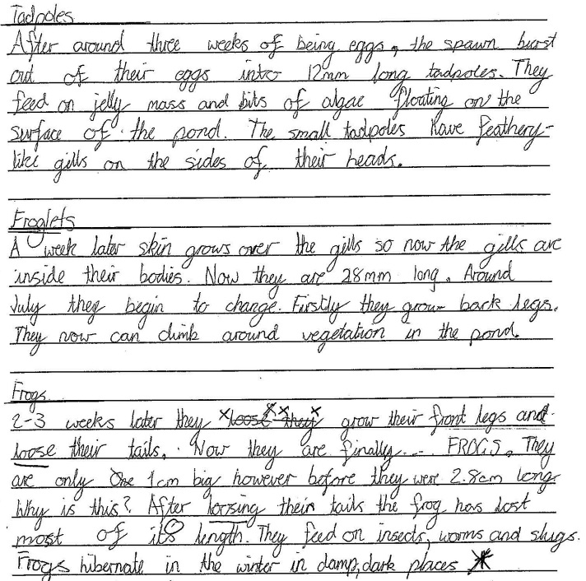 | Cluster 12

Purpose - Devices
Cluster 9  Imaginative – Brief description of a character and setting but lacks consistency. (NAP)  Informative – Some correct use of technical language. Graphic, pictures, tables, and charts, etc are present and are mostly supplementary to understanding the text (NAP)  Persuasive – Uses a statement or statements of personal opinion AND/OR one or two devices (NAP) |  | Cluster 10  Imaginative – creates imaginative texts based on characters, settings and events from students' own and other cultures EN2-2A  Informative –  Persuasive –express a point of view for a particular purpose in writing, with supporting arguments and make constructive statements that agree/disagree with an issue EN2-7B
Cluster 11  Imaginative – Experiments with the use of imagery in imaginative texts, poetry and songs, eg similes, metaphors, personification and sound devices such as alliteration EN3-2A  Informative –  Shows evidence of developed ideas EN3-2A  Persuasive- Include sustained and effective use of persuasive devices, eg texts dealing with environmental issues EN3-2A |  | Cluster 12  Imaginative – Selects some sophisticated and subtle literary devices (e.g irony, humour)  to engage and influence an audience.(CL12)  Details of characters are selected to create realistic characters. Maintains are setting throughout. (NAP)  Informative – Use of technical language is integral to the text.  Graphics support or are integral to understanding the text. (NAP)  Persuasive – Uses some devices that persuade. Use is effective but not sustained (may also include some ineffective use) (NAP) | 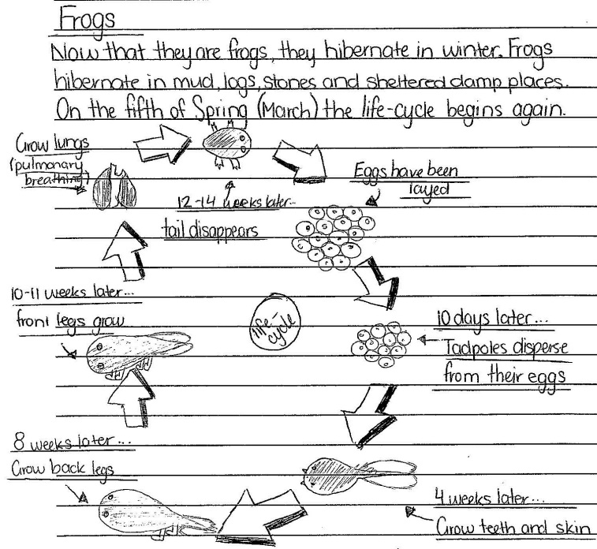
Language Features - Vocabulary
Cluster 9  Uses verbs, adverbials, nouns and  adjectives to express specific ideas and  details.(CL9)  Experiments with figurative language when composing texts to engage an audience, eg similes, metaphors, idioms and personification EN2-9B |  | Cluster 10  Adapts language features and patterns encountered in literary texts, for example characterisation, rhyme, rhythm, mood, music, sound effects and dialogue EN2-2A  Incorporates new vocabulary from a range of sources into students' own texts including vocabulary encountered in research EN2-9B
Cluster 11  Selects appropriate language for purpose,  e.g. descriptive, persuasive, topic, technical,  evaluative, emotive, and colloquial. (CL10) EN3-6B | 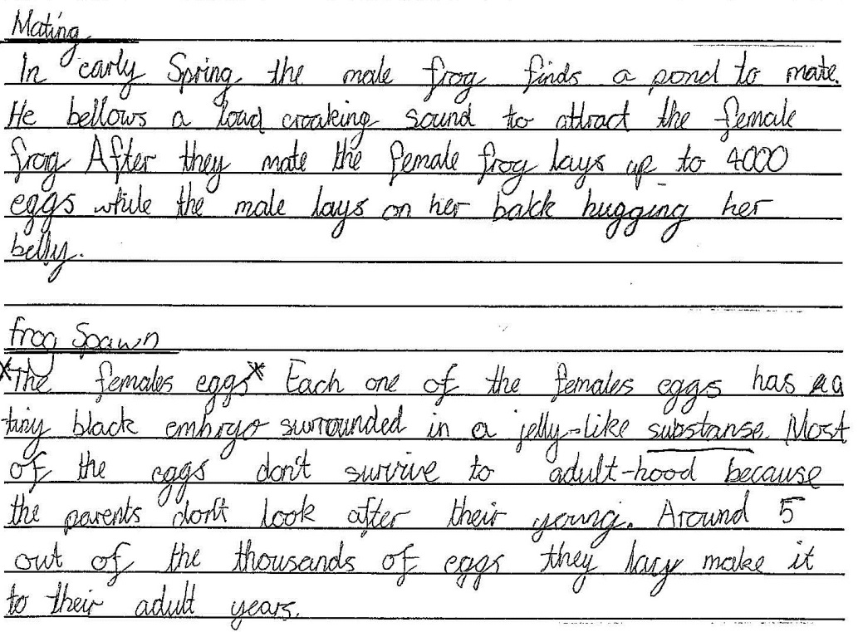 | Cluster 12  Selects some sophisticated and subtle language features (CL12)  Ideas and points of view in texts are conveyed through the use of vocabulary, including idiomatic expressions, objective and subjective language EN3-6B  Sustained and consistent use of precise words and word groups that enhance meaning (may be some inaccurate or inappropriate word groups) (NAP)

Language Features - Cohesion
Cluster 9 |  | Cluster 10  Uses grammatical features such as  pronouns, conjunctions and connectives to  accurately link ideas and information. (CL10) EN2-9B | 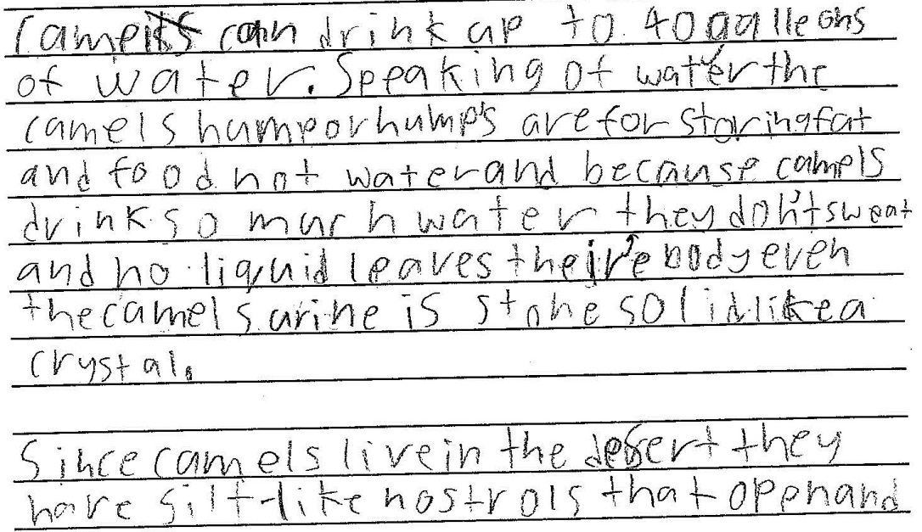
Cluster 11  Cohesive links are made in texts by omitting or replacing words EN3-2A |  | Cluster 12  A range of cohesive devices is used correctly and deliberately to enhance reading and support underlying relationship. An extended, highly cohesive piece of writing showing continuity of ideas and tightly linked sections of text (NAP)

Language Features - Paragraphing
Cluster 9  Paragraphs are composed  of logically grouped sentences are focused  a particular aspect of a topic. (CL9)  At least one paragraph is logically constructed and contains a topic sentence and supporting detail paragraphs are correct but basic. (NAP) | 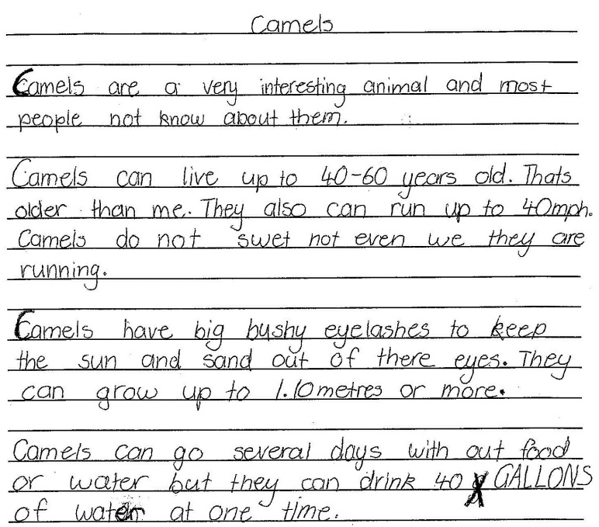 | Cluster 10
Cluster 11  Uses topic sentences and appropriately  organises main and subordinate ideas.(CL10) EN3-6B | 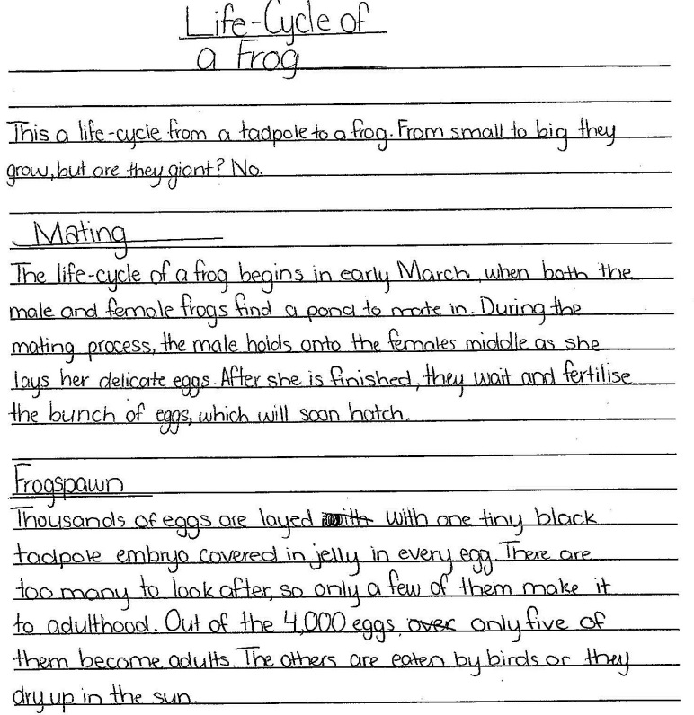 | Cluster 12  Paragraphs are ordered and cumulatively build ideas across text (NAP)

Language Features – Sentence Structure
Cluster 9  Simple and compound sentences are correct and most complex sentences are correct. Meaning is clear. (NAP)  Uses grammatical features to create complex sentences when composing texts EN2-9B | 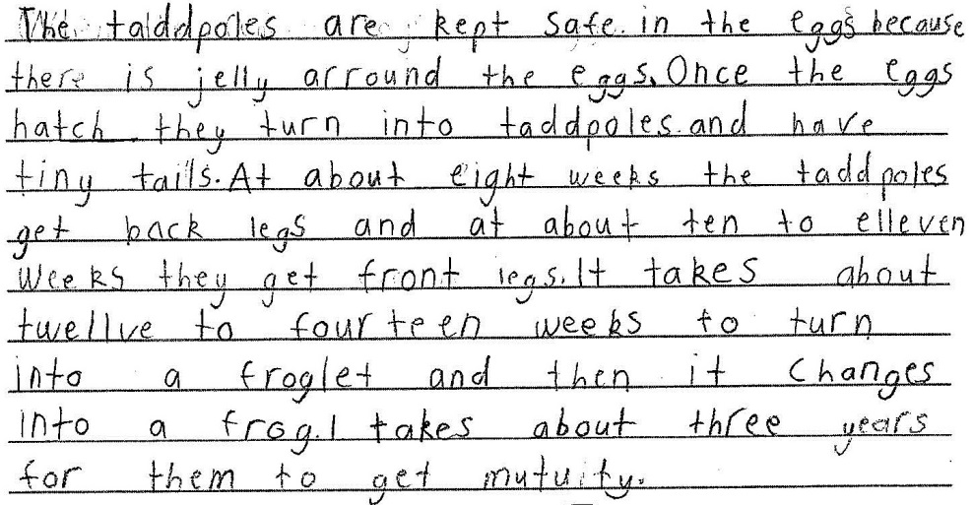 | Cluster 10  Creates meaningful sentences using a  variety of sentence beginnings, including  adverbial and adjectival clauses to create  complex sentences.(CL10)
Cluster 11  Sentences correct. Demonstrates variety. Meaning is clear and sentences enhance meaning. (NAP)  Complex sentences can be used in a variety of ways to elaborate, extend and explain ideas EN3-2A |  | Cluster 12  Makes sentence level choices (e.g. short  sentences to build tension; complex sentences  to add detail) using a variety of sentence  beginnings and dependent clause .(CL12)  All sentences are correct. Writing contains controlled and well-developed sentences that express precise meaning and are consistently effective (NAP)  Uses different types of sentences, eg short sentences to build tension and complex sentences to add detail EN3-6B

Language Features - Punctuation
Cluster 9  Sentence level punctuation mostly correct (minimum of 80% of 5 sentences  punctuated correctly) AND some other correct punctuation (two or more examples of different types of other punctuation) (NAP) |  | Cluster 10  All sentence punctuation correct. Mostly correct use of other punctuation (NAP)  Uses sentence and simple punctuation  correctly. (CL10)
Cluster 11  Experiments with using complex punctuation to engage the reader and achieve purpose. (CL10) |  | Cluster 12  Uses a range of punctuation to enhance meaning and clarity, including the use of brackets to enclose additional information, quotation marks and commas to indicate  clauses.(CL12)

Language Features - Spelling
Cluster 9  Uses a variety of spelling strategies to spell high frequency words correctly. (CL9) | 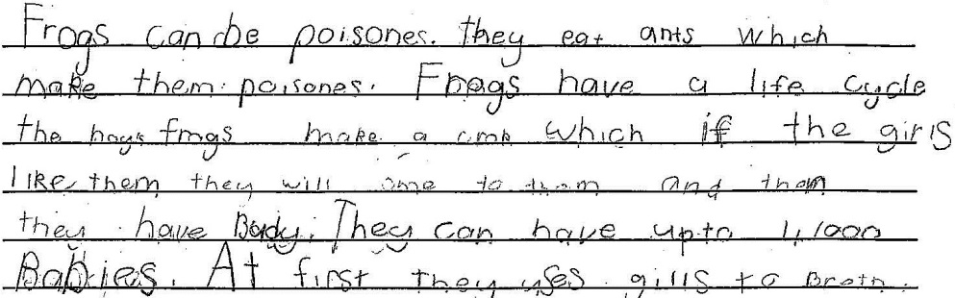 | Cluster 10  Correct spelling of most simple words and most common words. (NAP)  Uses morphemic, visual, phonic knowledge and knowledge of prefixes and suffixes to spell and edit words.(CL10)
Cluster 11  Correct spelling of simple words, most common words, some difficult words (NAP)  Applies knowledge of generalisations,  meanings of base words and word parts  (prefixes and suffixes) to spell new words. (CL10) |  | Cluster 12  Integrates a range of spelling strategies and conventions to accurately spell most words, including words of many syllables.(CL12)  Correct spelling of simple words, most common words, at least 10 difficult (NAP)

